This part of the takes the user input and stores it into variables. i.e. each box in the user interface represents these variables:

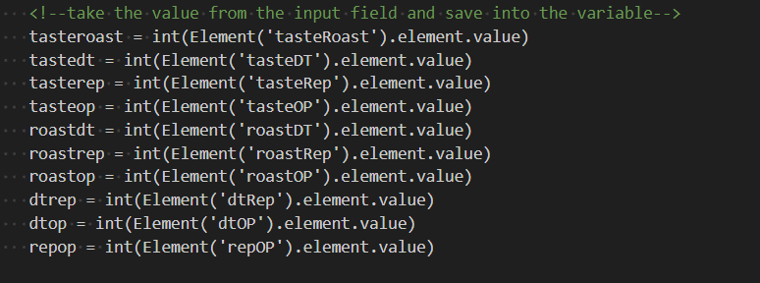

Next we build this table from the user input:  
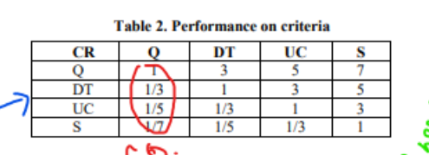

Which is pointed by the following code. This just creates a table internally for our ease of writing the code and doing the maths:

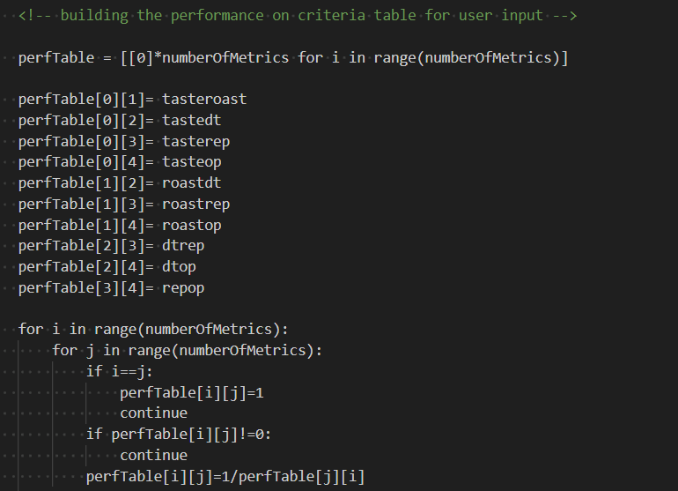

Next we create this table internally:

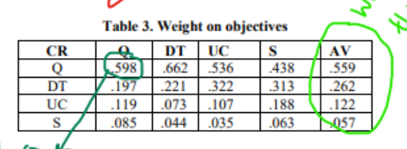

The corresponding code for this table is:

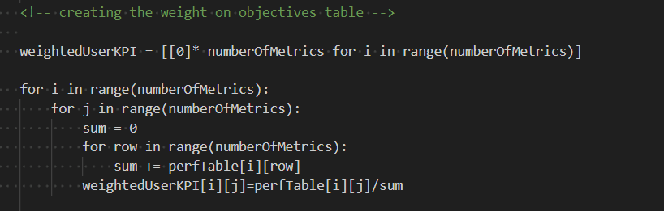

Next I used the excel sheet (the dummy sheet to test the initial code). The client can bring his data and upload it in the application and get values. The Excel sheet need not be same throughout. A client can bring his data as well. This is something I discovered while trying to make the app flexible.

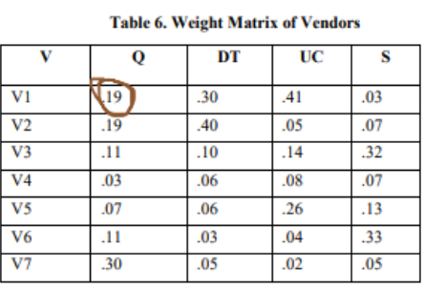

Corresponding code to be used internally by system (That print line at the end was just to see if this code is working, we don’t need to print anyways):

